MB-010 Committee – Proposed update dispute resolution provisions in AS 4000

Proposed drafting instructions for dispute resolution clause

- Proposed drafting instructions

  - Default position is as per the current dispute resolution mechanism within clause 42 of AS 4000 (amended as shown below), namely:

    - Step 1: Either party can give a notice of dispute;

    - Step 2: Parties to confer (ie negotiate) to resolve the dispute or agree on methods to do so;

    - Step 3: If the dispute has not been resolved within 28 days of notice of dispute, the dispute is referred to arbitration:

      - If parties have not agreed arbitrator within 14 days of reference to arbitration, arbitrator is to be nominated by person identified in Item 32(a) (or, if no one stated the President of Australasia Dispute CentreResolution Institute)

      - Rules for arbitration will be as stated in Item 32(b) (or, if nothing stated:
        - the Resolution Institute Arbitration RulesRules 5-18 of the Rules of The Institute of Arbitrators, Australia for the Conduct of Commercial Arbitrations; or
        - [if the parties are from different countries], the UNCITRAL Arbitration Rules.

  - The new clause will allow the parties to alter the default position in the following four ways. A
    - add mediation as a step before proceeding to arbitration; or
    - add expert determination as a step before proceeding to arbitration; or
    - add both mediation and expert determination as steps before proceeding to arbitration.
    - add a Dispute Avoidance Board that has both a dispute avoidance function and a determination function, before proceeding to arbitration.

  - As such there would be five alternative dispute resolution processes, depending on the Option(s) selected. Flow charts for each of the five alternative processes are as follows.
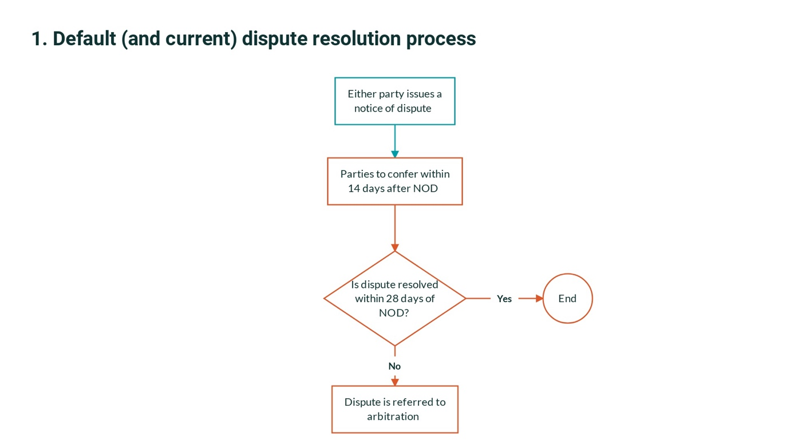

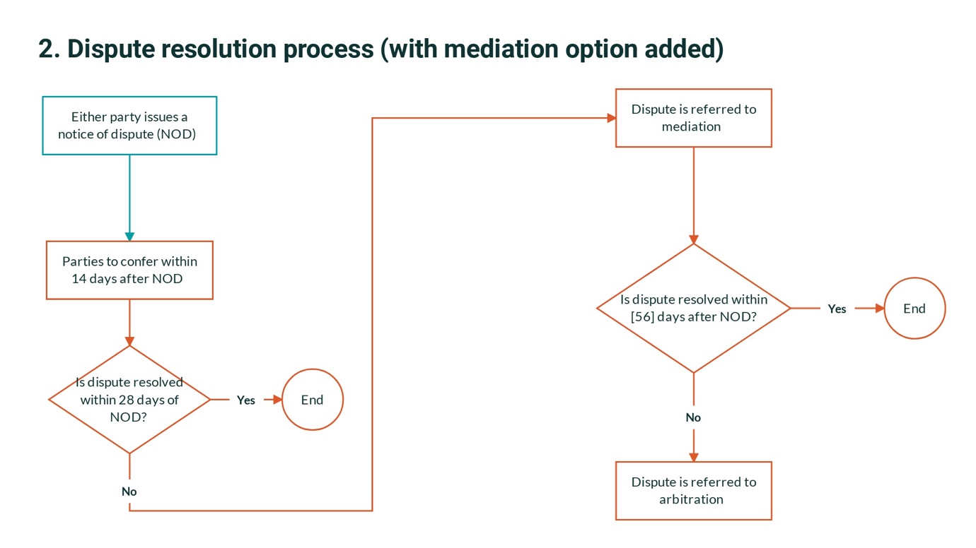

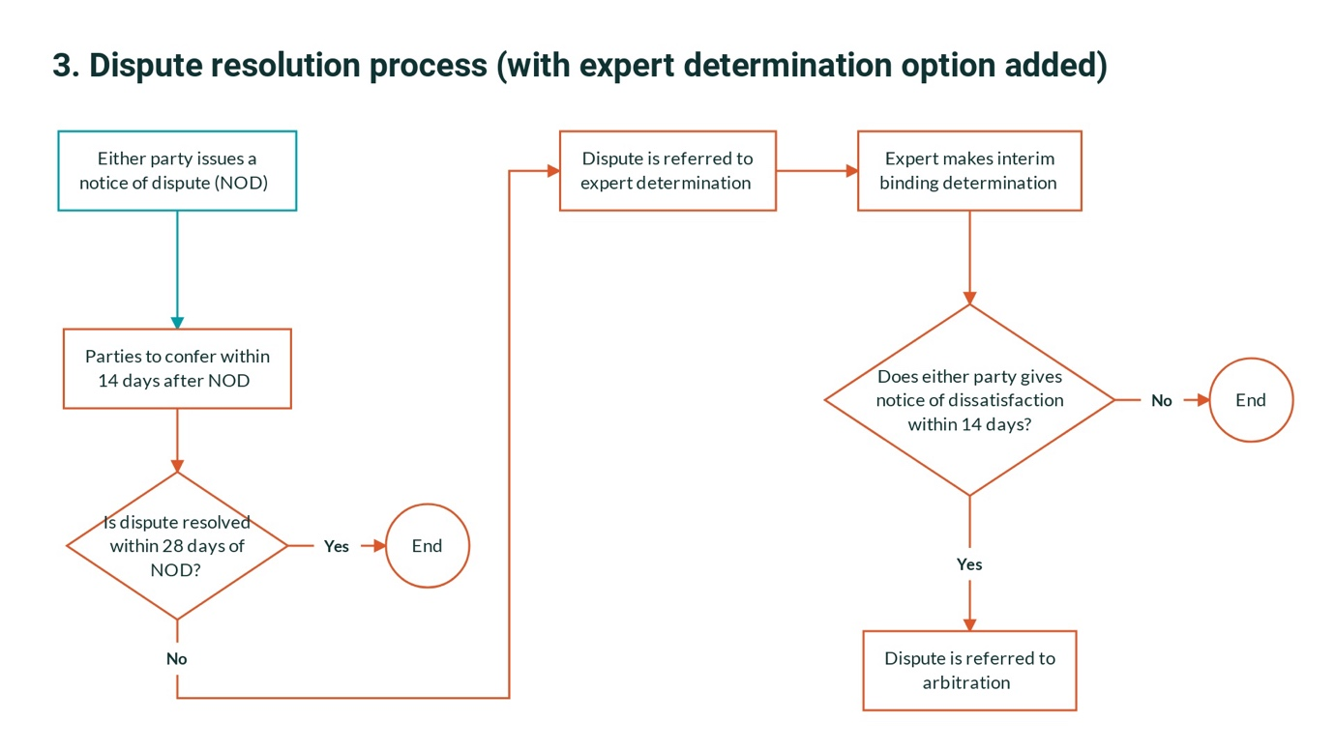

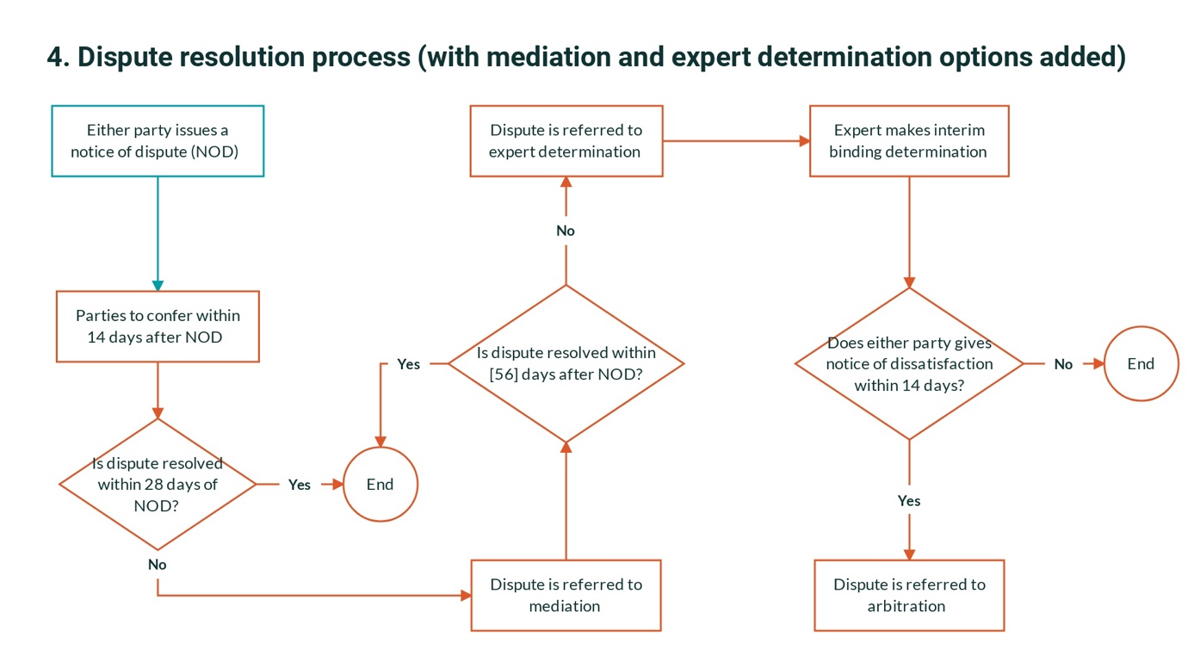

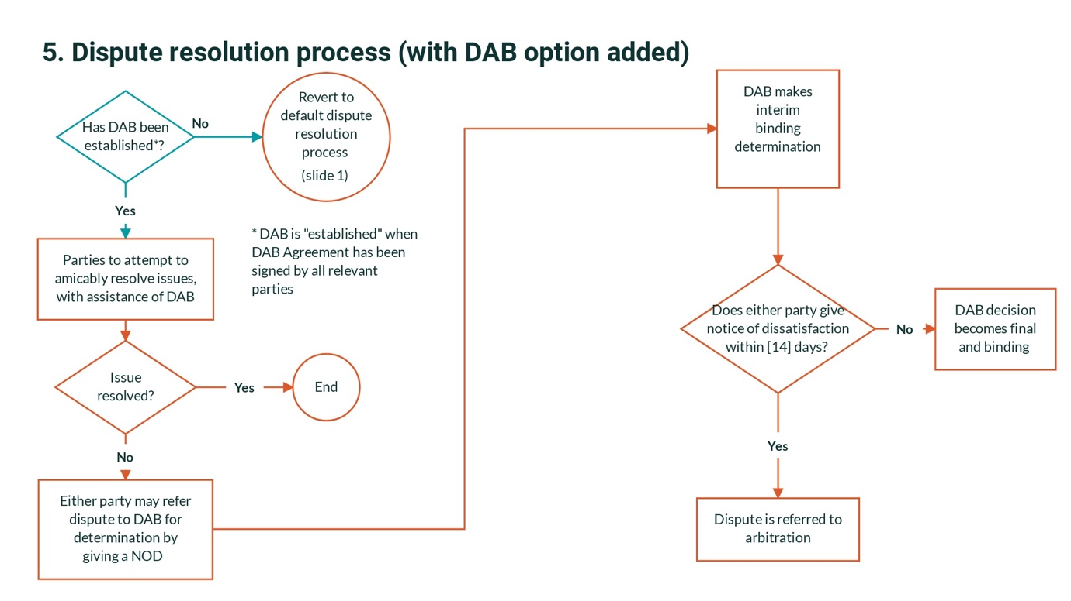

- Options

  - The AS4000 standard will encourage the parties to agree upon the options they wish to use (and upon any variants within an option) at the time the contract is executed, by selecting the relevant options and completing the necessary variables within Annexure Part A.
  - If no options are selected, the default dispute resolution process (see para 1.1) will apply.
  - Similarly, if the parties have selected the DAB option, but have not yet executed the DAB Agreement at the time a dispute arises, then the default process will apply.

- Negotiation

  - As per existing clause 42.2, but suggest we change “confer” to “negotiate in good faith”, to reflect plain english, common usage and case law that support the enforceability and content of an obligation to negotiate in good faith to resolve a dispute (United Group Rail Services v Rail Corporation of New South Wales [2009] NSWCA 177).

  - As per existing clause 42, this option will be the default option for Step 2 of the process.

  - No variants within the “negotiation” step (eg different levels of negotiator), to minimise complexity.

  - The negotiation process should allow the parties to reach agreement on an alternative process for the resolution of their dispute (as per the current standard, clause 42.2, first sentence). Doing so allows the parties (by agreement) to tailor the dispute process to the particular dispute.

- Mediation

  - This option to only apply if selected by the parties. Not a default option.

  - Parties to be able to nominate their:

    - mediation rules; and
    - place of mediation.

Parties to agree upon the mediator at the time the mediation is required (Resolution Institute to decide, if the parties cannot agree).

  - Default rules (if none stated, in Annexure Part B) will be Resolution Institute Mediation Rules

Under the current (2016) version of these Rules:
    - The mediator will appointed by Resolution Institute (unless the parties have agreed on the name of a mediator). Mediator does not need to be affiliated with Resolution Institute.
    - Mediator proposes conditions of appointment and requests agreement of parties to them.
    - Either party may refer the dispute to mediation by giving notice to the other party.
    - No express restriction on mediator acting in subsequent dispute resolution proceedings.

  - The standard should state that the mediator cannot act in subsequent proceedings, unless the parties agree otherwise.

  - If a Dispute Avoidance Board is selected as a dispute resolution option, then Mediation ceases to be appropriate as a dispute resolution option, because the dispute avoidance function of a DAB is in many (but not all) respects akin to mediation, in that it is a wholly consensual process. Accordingly, Annexure Part A to be set up so that Mediation cannot be selected if a DAB is selected.

- Expert determination

  - Expert determination is similar to the second function of a DAB, so suggest the standard is structured so that it can’t be selected as an option if the DAB option is selected.

  - Wholly a creature of contract, so clause and rules etc needs to be comprehensive to be enforceable.

  - Can be interim binding, or final and binding. Suggest we provide for interim binding 0only in standard form (to minimise variants). Parties can always amend the form if they want ED to be final and binding.

  - Some parties prefer to use ED for certain types of disputes only. Suggest the standard does not provide this level of sub-optionality, given the additional complexity and the higher risk of disputes about the dispute process, especially for ‘mixed’ disputes involving several issues. Has been used all disputes under a construction contract (eg GC21).

  - Parties to be able to nominate their expert determination rules. No need to nominate a place of expert determination, as no hearing.

  - Parties to agree upon the expert at the time the expert determination is required (Resolution Institute to decide, if the parties cannot agree).

  - Default rules and form of agreement (if none stated, in Annexure Part A) to be Resolution Institute Expert Determination Rules

The current (2016) Rules provide:
    - Resolution Institute nominates expert, unless parties have otherwise agreed.
    - Expert proposes conditions of appointment and requests agreement of parties to them.
    - Unless parties agree otherwise, determination of expert is final and binding.
    - Disputes in respect of rules or process to be determined by expert.
    - Subject to law or agreement to contrary, the expert determines/controls process. ;
    - Each party pays its own costs of process, unless otherwise agreed.
    - Expert cannot, without consent of parties, act in subsequent arbitral or judicial proceedings in relation to dispute.

  - Annexure Part A to require the parties to specify whether the procedure in Schedule B of the Rules will or will not apply. Default option to be “will not” (as per Rules)

- Dispute Avoidance Board

  - Annexure Part A to allow parties to select this as an option. Annexure Part A to provide that the options for mediation and expert determination cannot be selected if the DAB option is selected.

  - Clause to require the parties to establish the DAB, by entering into a DAB Agreement with the DAB member(s) at the time the contract is executed or as soon as possible thereafter.

  - Clause to provide that if the DAB is not established, or the DAB agreement has been terminated and not yet replaced with another DAB Agreement, then the default dispute resolution process will apply.

  - Once the DAB is established, the default dispute resolution process is replaced with the following:
    - Step 1: regular DAB meetings, during which parties attempt to amicably resolve all issues;
    - Step 2: either party may give a Notice of Dispute (whether or not the issue the dispute has been discussed as a DAB meeting);
    - Step 3: dispute is referred to DAB for determination;
    - Step 4: if either party gives a notice of dissatisfaction within 28 days after DAB decision, dispute is referred to arbitration

  - Annexure Part A to require the parties to specify whether the DAB is a ‘one-person DAB” or a ‘three-person DAB’. The default position will be a 3-person DAB.

  - Annexure Part A to allow the parties to agree and insert the names of all DAB members.
    - If the names are not completed and a single person DAB is specified, the parties must agree the identity of the DAB member. Until such time as the DAB Agreement is executed, the default dispute resolution process will apply.
    - If the names are not completed and a three-person DAB is specified, each party will nominate one DAB member (to be approved by other party), and the two nominated (and approved) DAB members will nominate the third member. The third DAB member will also be the chair, unless the DAB members unanimously agree otherwise.

  - If a 3-person DAB is chosen, the parties and the DAB members will enter into DRBF Region 3’s Pro-Forma DAB Agreement. If a 1-person DAB is chosen, the parties and the DAB member will enter into DRBF Region 3’s Pro-Forma DAB Agreement (One Person). In each case, as available on the DRBF R3 website at the relevant time: https://drbf.memberclicks.net/region-3-precedents---db-clauses.

  - Clause to provide that any decision of the DAB will be ‘interim binding’, i.e binding until such time as a party issues a notice of dissatisfaction, in which event the dispute will be referred to arbitration. Either party may issue a notice of dissatisfaction within 28 days after the DAB decision is issued. DAB decision is final and binding if no notice of dissatisfaction is issued within the 28 day period.

- Arbitration

  - Parties to be able to nominate:

    - arbitration rules;
    - place of mediation. (Use “place” of arbitration, instead of ‘seat’ of arbitration, as plain English).

  - Default rules (if none stated, in Annexure Part B) to be Resolution Institute Arbitration Rules, in all cases. There is no need to retain the separate default option of the UNCITRAL Arbitration rules for disputes between international parties.

The current (2020) version of these rules:
      - are based on the UNCITRAL Rules;
      - are consistent with the Commercial Arbitration Act in each state and territory and the International Arbitration Act;
      - provides for one arbitrator, unless the parties agree otherwise;
      - are silent on the potential for consolidation of arbitrations between different parties (eg contractor and sub-contractor)
      - do not permit an arbitrator to appoint and expert without consent of both parties;
      - either party can initiate by written notice;
      - arbitrator is selected by Resolution Institute, if not agreed by parties;
      - arbitrator can determine seat of arbitration if not agreed between the parties;

Attachment 1 – Owen’s original discussion paper (November 2022)

MB-010 Committee – Proposed update dispute resolution provisions in AS 4000

Discussion Paper on potential drafting instructions

- Background

  - The current dispute resolution mechanism within clause 42 of AS 4000 is:

    - Step 1: Either party can give a notice of dispute;

    - Step 2: Parties to confer (ie negotiate) to resolve the dispute or agree on methods to do so;

    - Step 3: If the dispute has not been resolved within 28 days of notice of dispute, the dispute is referred to arbitration:

      - If parties have not agreed arbitrator within 14 days of reference to arbitration, arbitrator is to be nominated by person identified in Item 32(a) (or, if no one stated the President of Australasia Dispute Centre)

      - Rules for arbitration will be as stated in Item 32(b) (or, if nothing stated:
        - the Rules 5-18 of the Rules of The Institute of Arbitrators, Australia for the Conduct of Commercial Arbitrations; or
        - [if the parties are from different countries], the UNCITRAL Arbitration Rules.

  - On 16 November 2022, the Committee determined that it would be useful to revisit the dispute resolution mechanism for several reasons voiced at the meeting. Owen Hayford offered prepare a discussion paper that would attempt to capture the matters discussed and provide a basis for further discussion at the next Committee meeting in December. This document serves this purpose. It has also been drafted so that, once it is settled, it can become the drafting instructions for the new dispute resolution provisions.

- Objectives of new dispute provisions

  - The objectives of the new dispute resolution provisions are to:

    - Recognise that there are a wide variety of dispute avoidance and resolution mechanisms in regular use for construction contracts and that AS4000 should provide parties with an ability to use the most common mechanisms, including mediation, dispute boards, expert determination, arbitration and litigation;

    - Be brief, and adopt rules and/or template agreements published by recognised dispute resolution bodies where possible (rather than re-invent the wheel);
    - Recognise that dispute resolution bodies that publish such rules and/or template agreements are in the business of ensuring that such documents reflect best practice from time to time;

    - Be drafted so as to minimise the possibility of disputes in respect of the dispute resolution process.

    - Be drafted, in the case of a sequential dispute resolution process, so as to minimise the possibility of the parties ‘getting stuck’ within a step (for example, by tying timeframes to the initial notice of dispute).

- Options

  - The standard should encourage the parties to agree upon the options they wish to use (and upon variants within an option) at the time the contract is executed, by selecting the relevant options and completing the necessary variables within Annexure Part A.

  - In broad terms, the dispute avoidance and resolution options that should be available to the parties under the standard should include the following. For some of these options, there are sub-options, discussed further below:

    - Negotiation;
    - Mediation;
    - Dispute Avoidance Board;
    - Expert Determination;
    - Arbitration;
    - Litigation.

  - It is suggested that the default option (if no other option(s) are selected) should be:

    - Step 1: Notice of Dispute;
    - Step 2: Negotiation;
    - Step 3: Litigation,

because this is simple, and other options can be easily added or substituted. A number of committee members suggested that arbitration was no longer optimal as a ‘default’ process.

- Negotiation

  - As per existing clause 42.2, but suggest we change “confer” to “negotiate in good faith”, to reflect plain english, common usage and case law that support the enforceability and content of an obligation to negotiate in good faith to resolve a dispute (United Group Rail Services v Rail Corporation of New South Wales [2009] NSWCA 177).

  - As per existing clause 42, this option will be the default option for Step 2 of the process (if no other option is selected).

  - Suggest we avoid other options within the “Negotiation” option (eg different levels of negotiator), to minimise complexity.

  - The Negotiation process should allow the parties to reach agreement on an alternative process for the resolution of their dispute (as per the current standard, clause 42.2, first sentence). Doing so allows the parties (by agreement) to tailor the dispute process to the particular dispute.

- Mediation

  - This option to only apply if selected by the parties. Not a default option.

  - Parties to be able to nominate their:

    - mediation rules; and
    - place of mediation.

  - Suggest that we don’t allow the parties to pre-agree the mediator in Annexure Part A as:

    - preferred mediator may not be available at required time;
    - Likely to give rise to retainer issues etc.

Better for the parties to agree upon the mediator at the time the mediation is required (and for ACICA to decide, if the parties cannot agree).

  - Default rules and form of agreement (if none stated, in Annexure Part B) to be stated. Potential options include:

    - Resolution Institute Mediation Rules. Under the current (2016) version of these Rules:
      - The mediator will appointed by Resolution Institute (unless the parties have agreed on the name of a mediator). Mediator does not need to be affiliated with ACICA.
      - Mediator proposes conditions of appointment and requests agreement of parties to them.
      - Either party may refer the dispute to mediation by giving notice to the other party.
      - No express restriction on mediator acting in subsequent dispute resolution proceedings.

    - ACICA Mediation Rules. Under the current (2007) version of these Rules:

      - Mediation will be in Sydney, unless the parties have agreed otherwise;
      - There will be one mediator, unless the parties have agreed otherwise;
      - Either party may refer the dispute to mediation by giving ACICA a Request for Meditation;
      - The mediator will appointed by ACICA (unless the parties have agreed on the name of a mediator). Mediator does not need to be affiliated with ACICA.
      - A party can only initiate arbitral or judicial proceedings during the mediation process for the purposes of enforcing its rights under the ACICA Mediation Rules or to seek interlocutory relief.
      - Mediator cannot act in subsequent arbitral or judicial proceedings in respect of the dispute.

    - ADC Guidelines for Commercial Mediation. Under the current (2019) Guidelines:
      - Place of mediation is ADC (Lockhart Chambers, 233 Macquarie Street, Sydney) unless the parties agree otherwise.
      - Either party can refer the dispute to ADC for mediation if not resolved within 7 days of receipt of Notice of Dispute.
      - Mediator needs to be affiliated with ADC as ADC proposes potential mediators. Parties select from those proposed by ADC. ADC decides if parties don’t agree.
      - Mediator cannot act in subsequent arbitral or court proceedings or expert determination in respect of the dispute.
      - ADC provides the parties with the draft Mediation Agreement

  - Suggest that Resolution Institute Mediation Rules be the default option, as:
    - Resolution Institute supersedes the default body for arbitration in the 1997 standard;
    - Mediator need not be affiliated with appointing body;
    - Resolution Institute also provides good rules for Expert Determination and Arbitration processes.

But the standard should state that the mediator cannot act in subsequent proceedings, unless the parties agree otherwise.

  - Mediation option needs to be followed by another Step, as the mediation process may not resolve the dispute. Set up Annexure Part A so that this option can only be selected as Step 3 (to follow Negotiation) if the parties select ED, Arbitration or Litigation as Step 4.

  - If a Dispute Avoidance Board is selected as a dispute resolution option, then Mediation ceases to be appropriate as a dispute resolution option, because the dispute avoidance function of a DAB is in many (but not all) respects akin to mediation, in that it is a wholly consensual process. Accordingly, suggest Annexure Part A is set up so that Mediation cannot be selected if a DAB is selected.

- Dispute Avoidance Board

  - The Dispute Avoidance Board should be established at the time the construction contract is signed. As is usual in Australia, the DAB will have two functions, i.e:
    - a dispute avoidance function (i.e pro-actively helping the parties to consensually resolve their issues before they become the subject of a notice of dispute); and
    - a dispute resolution function (making a decision in respect of issues that become the subject of a notice of dispute).

  - Because a dispute board has these two functions, and the first function applies before a dispute becomes the subject of a formal notice of dispute, it is suggested that the standard should be drafted so that this option cannot be combined with:
    - the default option (i.e NOD, followed by Negotiations, followed by Litigation); or
    - Negotiations; or
    - Expert Determination (as the decision-making function of the DAB is akin to ED).

  - The parties should agree and specify the names of the DAB members in Annexure Part A. Annexure Part A should require the parties to specify whether the DAB is a ‘one-person DAB” or a ‘three-person DAB’.

  - It is recommended that the parties jointly agree upon all DAB member(s), as this reduces perceptions of bias if each party appoints one member, and the two appointed members select the third.

  - If the parties have specified 3-person DAB but have not specified or otherwise agreed the 3 DAB members then each party will nominate one DAB member, and the two nominated DAB members will nominate the third member. The third DAB member will also be the chair, unless the DAB members unanimously agree otherwise.

  - If a 3-person DAB is chosen, the parties and the DAB members will enter into DRBF Region 3’s Pro-Forma DAB Agreement. If a 1-person DAB is chosen, the parties and the DAB member will enter into DRBF Region 3’s Pro-Forma DAB Agreement (One Person).

  - Each Pro-forma Agreement includes:

    - the Dispute Avoidance Board General Operating Procedures (in Appendix 1); and
    - the Rules for Dispute Avoidance Board Decisions (in Appendix 2).

In accordance with their terms, these default preocedures/rules will apply unless the parties and the DAB member(s) agree otherwise.

  - Under the Pro-forma DAB Agreements:

    - the frequency of DAB meetings is as agreed between the parties and the DAB member(s);
    - the first meeting should be held within one month of the date of the DAB Agreement;
    - DAB meetings are ‘without prejudice’; and
    - the parties can ask the DAB to issue non-binding advisory opinions, as part of its dispute avoidance function.

  - Decisions of the DAB can, depending on the election of the parties, be:

    - Advisory only (i.e non binding, unless the parties agree otherwise);
    - Interim Binding (i.e binding until such time as a party issues a notice of dissatisfaction, which notice must be issued within an agreed period of the decision); or
    - final and binding.

  - Annexure Part A should require the parties to select between these three sub-options. The default, if no option is selected, should be Interim Binding. If Interim Binding is selected, then the parties need to select a final step, which could be either arbitration or litigation. It is suggested (for simplicity, and ease of enforceability of the DR process) that litigation should be the default for the final step, if arbitration has not been selected.

  - It’s possible that the parties will fail to enter into the DAB Agreement. If this occurs, then the default dispute resolution mechanism (i.e NOD, Negotiation; Litigation) should apply.

- Expert determination

  - Expert determination is similar to the second function of a DAB, so suggest the standard is structured so that it can’t be selected as an option if the DAB option is selected.

  - Wholly a creature of contract, so clause and rules etc needs to be comprehensive to be enforceable.

  - Can be interim binding, or final and binding. Both sub-options should be provided.

  - If interim binding, could be followed by either arbitration or litigation. Suggest:

    - Interim binding (i.e binding unless notice of dissatisfaction is given within required timeframe of decision); and
    - litigation is the default option for next step, if arbitration is not selected.

This aligns with the proposal in respect of DAB decisions.

  - Some parties prefer to use ED for certain types of disputes only. Suggest the standard does not provide this level of sub-optionality, given the additional complexity and the higher risk of disputes about the dispute process, especially for ‘mixed’ disputes involving several issues. Has been used all disputes under a construction contract (eg GC21).

  - Parties to be able to nominate their expert determination rules. No need to nominate a place of expert determination, as no hearing.

  - As per mediation, suggest that we don’t allow the parties to pre-agree the expert in Annexure Part A as:

    - preferred expert may not be available at required time;
    - retainer issues etc.

Better for the parties to agree upon the expert at the time the expert determination is required (and for nominated body to decide, if the parties cannot agree).

  - Default rules and form of agreement (if none stated, in Annexure Part A) to be stated. Potential options include:

    - Resolution Institute Expert Determination Rules. The current (2016) Rules provide:
      - Resolution Institute nominates expert, unless parties have otherwise agreed.
      - Expert proposes conditions of appointment and requests agreement of parties to them.
      - Unless parties agree otherwise, determination of Expert is final and binding.
      - Disputes in respect of rules or process to be determined by Expert.
      - Subject to law or agreement to contrary, the Expert determines/controls process. The parties can agree that procedure in Schedule B applies. Suggest that Annexure Part A requires the parties to specify whether the procedure will or will not apply. Default option is “will not” (as per RI rules);
      - Each party pays its own costs of process, unless otherwise agreed.
      - Expert cannot, without consent of parties, act in subsequent arbitral or judicial proceedings in relation to dispute.

    - Australian Disputes Centre’s Rules for Expert Determination. The current (2019) Rules provide:
      - Notice of Dispute and Notice of Response to be given;
      - 14 days of conference to follow NOR;
      - Place of mediation is ADC (Lockhart Chambers, 233 Macquarie Street, Sydney) unless the parties agree otherwise.
      - Expert needs to be affiliated with ADC as ADC proposes potential mediators. Parties select from those proposed by ADC. ADC decides if parties don’t agree.
      - ADC provides the form of Expert Determination Agreement.

  - Suggest default position is for Resolution Institute Rules, consistent with paragraph 5.5.

- Arbitration

  - Suitable for final set of process. Suggest that litigation is the default option for final step, unless arbitration or (final binding) expert determination is selected for final step.

  - Parties to be able to nominate:

    - arbitration rules;
    - place of mediation. (Suggest we use “place” of arbitration, instead of ‘seat’ of arbitration, as plain English).

  - Suggest that we don’t allow the parties to pre-agree the arbitrator in Annexure Part A as:

    - preferred arbitrator may not be available at required time;
    - retainer issues etc.

Better (and more usual) for the parties to agree upon the arbitrator at the time the arbitration is required (and for nominating body to decide, if the parties cannot agree).

  - Default rules (if none stated, in Annexure Part B) to be stated. Potential options include:

    - Resolution Institute Arbitration Rules 2020. The current (2020) version of these rules:
      - are based on the UNCITRAL Rules;
      - are consistent with the Commercial Arbitration Act in each state and territory and the International Arbitration Act;
      - provides for one arbitrator, unless the parties agree otherwise;
      - are silent on the potential for consolidation of arbitrations between different parties (eg contractor and sub-contractor)
      - do not permit an arbitrator to appoint and expert without consent of both parties;
      - either party can initiate by written notice;
      - arbitrator is selected by Resolution Institute, if not agreed by parties;
      - arbitrator can determine seat of arbitration if not agreed between the parties;

    - ACICA Arbitration Rules. The current (2021) version of these rules:
      - allow ACICA to determine whether one or three arbitrators, if parties have not agreed;
      - are consistent with the UNCITRAL Rules;
      - provide for consolidation and joinder of arbitrations;

    - Australian Disputes Centre’s Rules for Domestic Arbitration. The current (2019) version of these rules is not necessarily suitable if the contract or dispute has international elements, so not recommended.

  - Suggest we use the Resolution Institute Arbitration Rules as the default rules, given it supersedes the current nominating body and is also proposed source of Mediation Rules and Expert Determination Rules.

- Litigation

  - Suitable for final set of process. Suggest that litigation is the default option for final step, unless arbitration or (final binding) expert determination is selected for final step.

  - Creature of common law. No need to agree rules etc.

- Summary

By way of summary, it is suggested that:

  - The default DR process, if other options are not specified will be:

    - Step 1: Notice of Dispute
    - Step 2: Negotiations
    - Step 3: Litigation.

  - To this default process, the parties can either:

    - Add Mediation as an additional step after Negotiations and before Litigation. [Suggest we don’t provide the option of replacing Negotiation with Mediation, unlikely to be selected often and adds complexity.];

    - Add (interim binding) Expert Determination as an additional step after Negotiations and before Litigation;

    - Replace Litigation with:
      - Arbitration; or
      - final Expert Determination.

  - Alternatively, the parties can replace the default process with Dispute Avoidance Board with decisions that are either:

    - Final and binding; or
    - interim binding; or
    - advisory only.

  - If parties select DAB with interim binding decisions or decisions that are advisory only, the parties must select either Arbitration or Litigation for final step. Litigation will be default option.

  - A flowchart might be an innovative way to how the options and encourage parties to make selections.

Attachment 2: Colin's discussion paper

MB-010: An approach for consideration by the committee in relation to developing a Dispute Resolution process for the updated AS4000 suite of documents.
- Preamble
I Thank Owen Hayford for providing the discussion paper which includes options available to resolve disputes.
This paper is proposing a particular approach to dispute resolution, for consideration by the committee.
The following approach mentions a number of ‘specified times’ that require further discussion. Disputes can vary substantially in complexity. Adequate times should be allowed to allow parties to complete their respective activities, but the dispute resolution process should be seen to be efficient and cost effective.
It is useful to get agreement on dispute resolution matters up front, when the contract is being established, rather than later when the relationship between the parties have deteriorated and agreements between the parties are more difficult to achieve.
Dispute procedures can be delayed when parties are required to agree on certain activities after disputes have arisen, eg when the responding party is being requested to pay more by the claimant and the respondent considers that the payment claim is not warranted.
Parties may agree on a particular process to resolve a dispute when a dispute arises, however a fall back/default position is needed when agreement is not achievable.
- Process associated with initiating a dispute
A dispute usually arises following discussions between the contracting parties, and after the Superintendent provides a decision which is not accepted by one of the contracting parties.
A dissatisfied party (usually the Claimant) then provides a Notice of Dispute to the other party.
- Proposed first step to resolve a dispute
I suggest that the dispute resolution process should be a ‘two-limb’ process.
The first step involves giving the parties the opportunity to resolve the dispute themselves within a specified time after the service of the notice of dispute, by
- conference between senior representatives of the respective parties initially, and/or
- by mediation if the conference fails to settle matters in dispute within a specified time after the service of the notice of dispute.
- The parties to be given an opportunity to agree on a mediator or, failing agreement, either party may request a nominating authority to nominate a mediator.
- Nominating authorities (such as the resolution Institute) have mediation rules for the conduct of mediations.
- Proposed second step to resolve the dispute
If the first step fails to resolve the dispute in a specified time after the service of the notice of dispute, then the dispute process to be resolved by either Expert Determination or Arbitration.
The parties to agree on one of these two alternative ‘determinative’ methods at the time that the contract is established, as the second limb of the dispute resolution process, if the first step fails to resolve the dispute.
The dispute is referred to either an expert or an arbitrator to provide a decision to resolve the dispute.
In addition, the parties may agree at the time the contract is established by nominating in the annexure the place where any future expert determination or arbitration will be held. This may be changed by later agreement between the parties, if a change is warranted.

- Expert Determination (first alternative)
If the parties cannot agree on an expert to conduct an expert determination within a specified time from the service of the notice of dispute, then either party may request the nominating authority named in the annexure to nominate an expert, and provide a notice to the other party regarding this request.
The nominee to advise the parties of his or her nomination promptly in writing (say within 7 days of receiving the nomination) and shall give written notice to the parties of a time and place for a preliminary conference. Alternatively, the parties my agree to conduct the preliminary conference by video.
The expert to conduct the process in accordance with expert determination rules provided by the nominating authority, or in accordance with a process agreed by the parties and the expert.
Prior to the preliminary conference the nominee may advise any conditions he or she wishes to impose (including provision of security for the fees and expenses of the nominee) and request the agreement of the parties to such conditions.
In the event that the parties agree to such conditions, the nominee may then accept appointment and shall then be deemed to have entered on the reference.
Unless otherwise agreed by the parties, the determination of the dispute shall be final and binding.
If the expert does not determine the matters in dispute within a specified time, the parties may agree to arbitrate the dispute or commence litigation in respect of the matters in dispute.

- Arbitration (second alternative)
If the dispute has not been resolved within a specified time from the service of the notice of dispute, and following completion of the first step, then the dispute to be referred to arbitration.
If the parties have not agreed on an arbitrator within a specified period of time, the arbitrator to be nominated by the nominating authority named in the annexure.
The arbitration to be conducted in accordance with the rules provided by the nominating authority.

Dispute resolution Boards
I understand that dispute resolution boards have been established early in the delivery of projects for the purpose of avoiding or minimising conflict and disputes during project delivery.
However, if disputes develop and the boards have not been successful in resolving the issues in dispute, then formal dispute resolution (such as expert determination of arbitration) may still be required to determine all the matters in dispute.

Colin Fullerton
The Institution of Engineers, Australia representative on the MB-010 Committee
FIEAust CPEng NER APEC Engineer IntPE(Aust) PRI
Accredited adjudicator, arbitrator, mediator and expert determiner
21 November 2022

