



Accessible Neighbourhoods Plan

Executive Summary

Regular physical activity is an important way of achieving and maintaining good health. Walking and cycling are effective low-cost ways of exercising. Obesity and physical inactivity are associated with a range of chronic diseases including diabetes, heart disease and some cancers, and its prevention is a major public health priority. Australia, like many developed nations, is currently experiencing an epidemic of people who are over-weight or obese. The causes of this epidemic are complex but involve the interplay of reduced physical activity, increased food intake and unhealthy food choices.

There is strong evidence to suggest that there are many health benefits from being active and it is recognised that physical activity plays a vital role in reducing the overall burden of disease (*Bauman: 2004*). The benefits of physical activity range from social benefits such as reduced isolation and depression, to reductions in the risks of acquiring chronic disease such as cardiovascular disease, non-insulin dependent diabetes, colon cancer, and reductions in rates of premature mortality *(US Department of Health and Human Services (USDHHS): 1996*).

However only about half the adult population of Australia is sufficiently active for health benefit, with 15% of Australians completely sedentary (*Brown: 2004*). Low levels of physical activity suggest that there is a greater need to address the determinants of physical inactivity at every level, from individual to social and environmental determinants. Recent research indicates that the environment where people live and work can have great influence on their activities. These influences include the distance to facilities, safety, the appearance of facilities, size of footpaths and sharing with other traffic, connectivity of footpaths and streets and the affordability and frequency of public transport. Providing accessible and attractive opportunities for physical activity should thus be viewed as a critical health-promoting strategy in the design and planning of the built environment. Increasing ‘walkability’ so that residents can satisfy basic needs within walking distance is an important means of reducing car dependency, increasing opportunities for regular physical activity and improving quality of life (*Jackson et al: 2002*).

This strategy suggest, through a series of principles, how to improve the current pedestrian and cycle network within the Hills Shire. The principles that have been identified are:

* Seek opportunities to **improve the health and well** **being** of the community by providing safe, usable and aesthetically pleasing tracks and trails
* Connecting important destinations throughout the network by **creating walkable neighbourhoods**
* Fostering community spirit by ensuring that the community will **easily identify the network** that has been provided for their use
* Provide a walking and cycling **network that is safe** enough for parents to take children on most routes
* **Support cycling** as a legitimate use of local streets, parks and other public places whilst recognising that pedestrians have priority over cyclists
* **Promote** the tracks and trails available encouraging the community to get out and get active

Table of Contents

Introduction 1

Background 1

Purpose and scope of the strategy 1

Project objectives 2

The community 2

Population analysis 2

Social trends 3

Recreation trends in general 4

Participation analysis of the shire 4

A vision for the health and well being of the community 5

Council’s vision 5

Health and well being of the community 6

Health benefits 6

Social benefits 7

Environmental benefits 7

Existing situation analysis 8

Existing footpath network 8

Existing cycle network 8

Existing walking trails 8

Regional Recreational Trails Network 9

Great North Walk 10

Great North Road (Convict Trail) 10

Great River Walk 11

Strategy direction and principles 12

Implementing the principles 12

Improving the health and well being of the community 12

Creating walkable neighbourhoods 13

Fostering community spirit 13

Branding the network 14

Design guidelines 14

Make connections 15

Create safe places for people to walk and cycle 15

Create stimulating and attractive routes 15

Design safe, accessible footpaths 16

Provide continuous footpaths 16

Shared path design 17

Streets 17

Slow traffic for safe streets 17

Provide safe places to cross streets 18

Support on road cyclists 18

Keep routes clear, direct and legible 19

Create attractive and welcoming streets 19

Seating 19

Signage 20

Lighting 20

Fencing and walls 21

Where to from here 21

Action plan 21

References 30

Definitions 31

Appendices 33

# Introduction

## Background

Council’s adopted Recreation Strategy has highlighted that walking ranked number one with a participation rate of 41.7% and cycling ranked five in the Shire in 2006, making them the most popular recreational activities for residents.

While opportunities for increased cycling are to be encouraged, walking is the more accessible form of physical activity, as it can be undertaken by people of varying levels of fitness and ability, including older people. It is typically conducted for two purposes; for recreation and as a form of exercise, and as a form of transport, where walking is incidental to the primary activity. Walking for transport may occur to key destinations in a locality such as bus stops and train stations, shops, services and facilities. The tendency to walk for transport and physical activity and recreation is influenced by a number of variables, including the existence of well maintained footpaths, shared paths, walking tracks and trails, street design particularly connectivity, urban amenity, safety and the presence of local destinations within walking distance (approx 800 m from home). The link between a healthy lifestyle and walking / cycling underpins this strategy. Research from Australia and overseas also shows significant tourism and economic benefits derived from a trail network. These benefits include expenditure in rural and regional areas, return visits and increased overnight stays by domestic and international tourists.

In the Shire’s transport system, walking and cycling play an important role. They provide viable alternates to private motor vehicles, particular when trips involve walking less than 3 km and cycling less than 10 km. They also let residents and visitors enjoy an outdoor lifestyle for recreation, fun and fitness.

Developing a tracks and trails strategy has been identified as a key project in the Recreation Strategy undertaken in 2007. A memorandum of understanding (MOU) with the Sydney West Area Health Service, signed in March 2008, exists to further develop the project.

## Purpose and scope of the strategy

The Accessible Neighbourhoods Strategy will build on the research and mapping undertaken for the *Environment and Leisure Direction*, and will identify the Shire’s network of walking trails, on-road and off-road cycle routes and possible new routes. The project scope will also consider commuter cycle routes, prepare new mapping and provide strategies to develop safe, accessible and enjoyable environments and experiences appropriate to the community through quality infrastructure such as paths, signage, rest areas and interpretive elements.

The strategy will also explore processes for improving the promotion and enhancement of the community’s awareness and use of tracks and trails within the Shire, and awareness of the health benefits of physical activity.

## Project objectives

The objectives of the strategy are to;

* **provide a strategic direction** for the ongoing development of shared pedestrian and bicycle pathways throughout the Shire and neighbouring communities
* **enhanced awareness** of the health benefits of physical activity
* **establish the preferred routes** for walking and cycling both locally and regionally
* **improve connectivity** that encourages people to travel by walking or cycling to local destinations
* ensure **an equitable and diverse range** of trails and tracks throughout the Shire, and
* increase the **promotion of service and facilities** available to our community

# The community

## Population analysis

As at the 2001 Census, Hills Shire consisted of **139,404** people with a 16.6% increase (19,859) between 1996 and 2001. In 2007 there where **167,228** people in the Shire and this is projected to be **235,000** by the year 2024. The recent recreation analysis suggests that:

Strong and sustained population growth will drive demand for access to additional parks, reserves, recreation facilities and services.

The majority of the population is within their most active years in terms of their potential use of sport, leisure and recreation facilities or services (average age of residents in the Shire is 35 years).

The high proportion of 0-11 year olds, and forecast continued growth in this age group, is expected to drive demand for access to age appropriate recreation facilities and services, for example playgrounds and junior sports development and participation opportunities.

The proportion of young people (12-24 years) remains high, approximately one fifth of the population. This age cohort tends to have one of the highest rates of participation in organised sports and activities. Demand for formal sporting opportunities will therefore remain high despite a slight decline in the overall proportion of the population in this age group from 1996 to 2001.

Demand for participation in formal sports and activities are expected to decline with age, consistent with industry trends and the age profile of the community.

The 35-49 year age group has a lower participation rate in formal organised sport compared to younger age groups, therefore facilities and services will need to provide a range of flexible, casual participation opportunities. There is likely to be high demand for walking paths and trails from this age group.

Facilities and services will need to be capable of adapting to the needs of an aging population, for example, demand for participation in formal organised sports and vigorous physical activities is expected to decline.

Community access to recreation facilities and services is not likely to be heavily influenced by socio-economic considerations in the Shire, such as low income, low educational attainment, high unemployment or jobs in relatively unskilled occupations. Therefore, the capacity of the community to access recreation opportunities on a ‘user pays’ basis is likely to be relatively high and there is likely to be relatively high demand for participation in informal, passive recreation opportunities (people from low socio-economic backgrounds tend to have a higher rate of participation in formal, organised team sports than those from higher socio economic backgrounds).

The central and western areas of the Shire will continue to experience population growth, particularly Kellyville, Castle Hill, Rouse Hill and Annangrove. Demand for services and facilities are likely to be greatest in these areas.

Recreation clubs and groups contribute to the social fabric of the community, particularly rural areas. Appropriate facilities and services may need to be maintained even in declining residential areas*[1]*.

## Social trends

On a broad scale, there are a number of key trends that influence people’s participation in leisure activities. The major social trends being:

* Greater emphasis is now being placed on preventative health care. More people are aware of the need for an active lifestyle
* Society is becoming convenience orientated and people are more interested in doing a greater range of activities at a time that is convenient to them
* Changing housing styles and sizes – larger houses on smaller blocks with no places for leisure activities or trees around the home
* Retail developments have focused on major shopping centres, with the consequent demise of strip shops and local stores. Whilst many young people are attracted to the new shopping centres, they are not welcome to hang out therefore hanging out in public spaces is expected to increase

## Recreation trends in general

More specifically are those recreation trends across the leisure industry. The NSW Department of Sport and Recreation suggest the following:

* Walking remains the most significant outdoor activity for adults. More dogs are accompanying walkers
* Whilst there has been an increase in the total number of people playing sports (as the population has increased) there has been minimal change in participation rates across the traditional sporting codes (tennis being the most notable exception)
* People are more interested in participating in individual and unstructured informal activities rather than in a team or group
* Issues of safety, security, vandalism and fear of crime affect the decisions people make regarding where and when they participate in recreation. It also affects the aesthetics of facilities as people feel safer in well maintained and secured places
* Greater demand for passive and non-competitive activities
* Greater emphasis on cultural activities – increased requests for Boche courts and information about the district (heritage walks)

## Participation analysis of the shire

The recent recreation needs analysis undertaken as part of the preparation of the Recreation Strategy (2007) allows a comparison between recreation participation use in 1995 and 2006. The following table compares the top ten popular activities.

|  |  |  |  |  |  |
| --- | --- | --- | --- | --- | --- |
| 1995 | | | 2006 | | |
| Rank | Activity | Participation Rate | Rank | Activity | Participation Rate |
| 1 | Walking | 33% | 1 | Walking | 42% |
| 2 | Swimming | 20% | 2 | Aerobic / Gym | 13% |
| 3 | Bushwalking | 18% | 3 | Swimming | 12% |
| 4 | Tennis | 15% | 4 | Running / Jogging | 11% |
| 5 | Picnic / BBQ | 14% | 5 | Cycling | 10% |
| 6 | Aerobics / Gym | 11% | 6 | Soccer | 7 % |
| 7 | Golf | 10% | 7 | Tennis | 7% |
| 8 | Cycling | 8% | 8 | Netball | 6% |
| 9 | Squash | 6% | 9 | Golf | 4% |
| 10 | Netball and Soccer | 5% | 10 | Cricket (outdoor) | 3% |

**Notes:** The increase in soccer over this period is a direct result of the promotion and growing popularity of women’s soccer which is one of the fastest growing sports state wide.

Bushwalking is included in the overall walking figures and the newer activity of Jogging/Running has significantly increased since 1995.

# 

# A vision for the health and well being of the community

## Council’s vision

The Council’s Strategic Plan identifies a series of community outcomes direct its provision of services and facilities. The Hills 2026 Community Strategic Direction is based upon extensive community consultation that creates a clear picture of where this community would like to be in the future. This direction is based upon community aspirations gathered throughout months of community engagement and consultations with people from all different walks of life.

The following statements from the Hills 2026 are relevant to tracks and trails.

*“Council works together with the community”*

* facilitate and develop strong relationships and partnerships with the community and other organisations.

*“Council’s finances and assets are efficiently managed”*

* manage and maintain assets and infrastructure under Council’s control to meet the needs of our community and future generations

*“There are places to play and be active”*

* manage and maintain a diverse range of well used and relevant open space settings, participation opportunities and recreation facilities
* promote health and well being and involvement in sport, recreation and leisure

*“I feel connected to the community”*

* provide opportunities to express and appreciate our local heritage and culture

*“There are services and facilities to suit my needs”*

* provide equitable access to a range of community services and facilities

*“I feel close to nature”*

* enhance and protect the Shire’s biodiversity
* encourage and facilitate community contribution to environmental protection
* ensure environmentally sustainable development practices are implements

# Health and well being of the community

## Health benefits

Regular moderate exercise can improve health and decrease the risk of developing certain conditions or diseases. The Heart Foundation identifies that the benefits of physical activity and those people who enjoy regular activity will lead to:

* a longer life expectancy and be less likely to have a heart attack
* feel more energetic
* have healthier blood cholesterol levels
* have stronger bones and muscles
* fell more confident, relaxed, happy and able to sleep better

More vigorous exercise, such as cycling, leads to better cardiovascular health.

Overweight and obesity are currently major health issues both in Australia and internationally. The prevalence of overweight and obesity is high and has been increasing over the last few decades. In Australian adults, the rate of overweight/obesity is around 49% and that of moderate to high levels of physical activity is only about 30%. Obesity and inadequate physical activity are major risk factors for many diseases including type two diabetes, stroke, certain cancers, and ischemic heart disease.

The built environment plays an important role in influencing participation in physical activity and obesity. Environmental factors such as well-maintained walking surfaces, residential density, public transport accessibility, public open space, and mixed land use are important correlates for higher rates of walking for recreation and transport. Neighbourhoods with higher walkability scores are associated with more walking. [2]

## Social benefits

There are many social benefits associated with creating pedestrian and cycling networks that include:

* bicycles are affordable for more and therefore more prevalent in communities
* cycling can provide a independent travel options especially for youth
* cycling networks increase accessibility for disable peoples
* with more people outdoors there is more opportunity for social interaction and a reduction in anti-social behaviour

## Environmental benefits

The environmental benefits of walking or cycling relate to the reduction of fossil fuel use associated with vehicle emissions. These benefits include;

* walking and cycling are pollution free activities and can reduce congestion on roads at peak times
* the majority of greenhouse gas emissions are associated with cold starts. if short trips are replaced by walking or cycling then there is a reduction in the number of cold starts
* for each kilometre cycled instead of driven greenhouse gas emissions are reduced by one third of a kilogram

# Existing situation analysis

## Existing footpath network

Most modern subdivisions throughout the Shire have an integrated network of footpaths and cycleways as part of the subdivision development. This unfortunately is not the case for older suburbs.

Council has for many years installed footpaths across the Shire on an, as needs, basis. More recently the footpath network has been subject to more rigorous analysis prior to being listed on the capital works program.

Footpaths nominated for inclusion into the works program are tested against a set of criteria developed to ensure the highest priority paths, that is, those that connect destination points such as school and shopping centres are given priority over footpaths suggested for cul-de-sacs or low pedestrian generating streets.

The criteria used to assess the priority for footpath construction is attached in the appendices of this strategy.

## Existing cycle network

In 1994, a Bike Plan was prepared by Arup Transportation Planning and Geoplan Urban & Traffic Planning. This plan was reviewed in 2009 to reflect the Shire’s growth and change in cycling demands.

The review identified the current bicycle network in the Hills Shire and reported on its deficiencies. Issues such as land use, characteristics of bicycle riders, transport issues in the Shire, availability of transport infrastructures that can be integrated with cycling, and Council’s current planning approach towards cycling are also reported. A general cycling profile of the Hills Shire was provided. A network of bicycle routes was developed, and aims at providing connectivity throughout the bicycle network.

The review concluded with a funding strategy to reduce the gaps in provision.

## Existing walking trails

The recreational needs analysis has identified that a high percentage of people in the Shire walk for pleasure, walk for exercise or, go bushwalking in the many bushland areas of the LGA. It is also noted that a high percentage of people drive short trips to school or shops that, with the right facilities could be made to be more attractive for walking.

The Shire contains many established shared walking trails through the major parks network. There is however an opportunity to continue to develop the trails network and provide a greater range of recreational experiences that are safe and well used.

The release area of Kellyville / Rouse Hill is dominated by the major open space link between the historic houses of Bella Vista and Rouse Hill House. This greenway link is the backbone of open space in this district linking the high points and historic points of interest along an 11 kilometre shared pathway network.

The following table identifies the current provision throughout the network.

|  |  |
| --- | --- |
| Facility | Kilometres |
| Footpaths | 344 |
| Bicycle Lane – roads marked with a dedicated cycle lane | 68.9 |
| Shared Street – local streets marked for cycle use | 29.6 |
| Off Road Cycle – cycle paths through bushland/open space | 22.5 |
| Shared Pathway – pathway used by pedestrians and cyclists | 82.1 |
| Bushwalking Trails – exclusive walking trails within bushland | 20.6 |
| **TOTAL:** | **567.7** |

## Regional Recreational Trails Network

On a national basis, the Australian National Cycling Strategy 2005-2010 has been prepared by Austroads on behalf of the Australian Bicycle Council to ‘encourage and facilitate increased cycling in Australia’. The strategy has the vision of enhancing the well being of all Australians through increased cycling for transport and recreation.

In NSW the RTA has developed the Action for Bikes (Bike Plan 2010). This master plan sets out to create a ‘network of cycle paths’, to promote safer cycling, and increase awareness of cycling. By these ‘the Government aims to ensure that cycling is a viable form of transport and a widely enjoyed means of recreation’ (RTA 1999).

The NSW Department of Infrastructure, Planning and Natural Resources (DIPNR) in 2004 published the NSW Planning Guidelines for Walking and Cycling. These are to assist Council’s in determining what to considerer when preparing land-use plans and assessing projects.

In 2005, the then Department of Infrastructure, Planning and Natural Recourses developed a regional recreational trails network. This strategy identified a major opportunity for the development of a regional trail called the Cattai Creek (North West) trail as well as a sub-regional corridor along Winsor Road.

### Great North Walk

The Great North Walk is a 250 kilometre trail from central Sydney to Newcastle. The trail starts in Macquarie Place and heading toward Circular Quay for a ferry ride. Its southern sections pass historic locations and heritage homes in the Sydney suburbs before arriving in the Lane Cove River National Park. The Great North Walk follows this river as far as Thornleigh and then the Berowra Creek before heading through part of the Ku-ring-gai Chase National Park to arrive at Brooklyn, on the Hawkesbury River.

The Walk’s middle sections through Brisbane Water National Park and the Ourimbah Valley before reaching the Watagan State Forest. Its final destination is central Newcastle.

Created in 1988, the Great North Walk is maintained by the NSW Government’s [Land and Property Management Authority](http://www.lands.nsw.gov.au/about_recreation/walking_tracks/great_north_walk).

An off shoot of the trail, known as the Governor Phillip Arm passes through the Shire connecting Mount Wilberforce Park at West Pennant Hills, the Cumberland State Forest, Bidjigal Reserve, Excelsior Reserve to Lake Parramatta.

### Great North Road (Convict Trail)

Extending north from Sydney to the Hunter Valley, the Convict Trail follows the route of the 240 km Great North Road, built between 1826 and 1836. Most of this road continues to be used today, offering an alternative, slower paced scenic route between Sydney and the Hunter, where one can explore the brilliant engineering works created by hundreds of convicts - many working in leg-irons.

Relics such as stone retaining walls, wharves, culverts, bridges and buttresses can still be seen along the entire length of the Great North Road - in Sydney suburbs like Epping and Gladesville, at Wisemans Ferry or Wollombi, Bucketty or Broke, or when walking in Dharug and Yengo National Parks.

Only 43 km of the road remains undeveloped and relatively intact. Running through the Dharug National Park and Yengo National Park, this section has been named the Old Great North Road. It goes from Wisemans Ferry in the south to Mount Manning (near Bucketty) in the north, and includes the oldest surviving stone bridges in mainland Australia. The road is closed to motor vehicles, but makes a great walk over two or three days - or an exhilarating day's cycle.

The Devine's Hill and Finch's Line sections of the Old Great North Road near Wiseman’s Ferry were World Heritage Listed in July 2010. The Old Great North Road is one of 11 historic sites that together form the Australian Convict Sites World Heritage Property.

The route through the Shire follows Old Northern Road from the Bull n Bush Tavern in Baulkham Hills to Wiseman’s Ferry.

### Great River Walk

The Great River Walk is a proposal from the Hawkesbury Nepean Catchment Management Trust to develop a walking trail from Brooklyn to Canberra along the Hawkesbury River. At its northern reaches it will connect to the Great North Walk developed by Department of Lands that links Newcastle to Sydney Cove.

The walking trail will be multifaceted with a number of different routes. It may be on both sides of the river. It will allow for the use of water craft to traverse the river so that people who use the route will be able to experience the river from the river bank and on the river.

The first section of the walk is currently being developed between Windsor and Bents Basin, which is a little upstream of Wallacia. The walk generally will be in the local government areas of Hawkesbury and Penrith. Both those areas have given their support for the walk.

One of the most important features of the development of the walk is the involvement of the indigenous people of the area.

# Strategy direction and principles

Council’s strategic direction for its pedestrian and cycle network are to:

***Provide outstanding opportunities for all people in our community to participate in a healthy and active lifestyle***

This will be achieved through the following principles:

* Seek opportunities to **improve the health and well** being of the community by providing safe, usable and aesthetically pleasing tracks and trails
* Connecting important destinations throughout the network by **creating walkable neighbourhoods**
* **Fostering community spirit** by ensuring that the community will easily identify the network that has been provided for their use
* Provide a walking and cycling **network that is safe** enough for parents to take children on most routes
* **Support cycling** as a legitimate use of local streets, parks and other public places whilst recognising that pedestrians have priority over cyclists
* **Promote** the tracks and trails available encouraging the community to get out and get active

# Implementing the principles

## Improving the health and well being of the community

Australian research indicates that healthy places and spaces contribute significantly to the mental and physical health of the community. The Healthy Spaces and Places guidelines have been prepared by collaboration between the Australia Local Government Association, the National Heart Foundation and the Planning Institute of Australia who have defined what health spaces look like.

Healthy places are:

* **aesthetically pleasing:** the attractiveness of a place affects the overall experience and use of the place, people are more likely to return to a place they enjoy
* **connected:** the ease with which people can walk and cycle between places
* **accessible by all:** places that accessible to everyone, regardless of age, ability, culture or income
* **safe places to be:** perceptions of safety influence the nature and extent that people will engage with the space, safer by design principles will increase the use of public places
* **based upon social inclusion principles:** a place where all people and communities are given the opportunity to participate fully in political, cultural and civic life become usable by all
* **sufficiently supported by appropriate infrastructure:** place that include infrastructure such as lighting, water fountains, signage, bike lockers, showers, toilets, shade, seating and shelter will attract a greater percentage of the population

## Creating walkable neighbourhoods

Walkable neighbourhoods make it easy and pleasant to use streets as an active form of transport and exercise. This reduces dependency on private motor vehicles, and the amount of space to accommodate them. Walkability also affects the social amenity and attractiveness of public spaces enjoyed by residents and visitors by increasing social street activity. A higher level of street activity improves the safety of pedestrians and reduces opportunities for vandalism and street crime.

The characteristics that create walkable neighbourhoods are:

* **permeability** – it takes less time to travel across the neighbourhood
* **variety** – refers to the mixture of experiences and landscape, and
* **legibility** - ease which someone who is walking can develop an understanding of the surrounding street layout

Improvement based upon the assessment of suburbs walkability can identify opportunities to improve the health and well being of the community.

## Fostering community spirit

The catch cry “build it and they will come” does not always work. In some instances and in this modern e-based community, information and opportunities to be part of the larger community, is what is expected by a great majority of the community.

Fostering a community spirit is about:

* Developing the built environment and community participation strategies that foster active communities and a sense of community spirit
* Engaging community members early in the planning process to accommodate their ideas about their local area
* Liaison with young people and children when planning new development areas or urban renewal projects.
* Obtaining community input into design features that encourage active transport, such as a walk to school groups, disability access groups or bicycle user groups
* Incorporating high quality community art programs into public spaces and buildings
* Designing spaces to accommodate community events and cultural development programs, such as walking and discussion groups, carols by candlelight and local arts or other festivals

## Branding the network

Walkable and rideable tracks are not just about providing connecting footpaths it is also about discovery, security and adventure. Through the development of a recognisable brand the community is able to explore a little further, discovery new routes and link information to new opportunities to participate.

Branding the network will involve:

* Developing a communications strategy that targets particular events, places and groups
* Developing a marketable brand that links the promotion of events and opportunities to available infrastructure
* Identifying trails (in literature and on the ground) that are suitable for commuters, adventurers, casual participants, children and the elderly

# Design guidelines

These design guidelines are based upon the national guidelines for **Healthy Spaces and Places** ( refer [www.healthyplaces.org.au](http://www.healthyplaces.org.au)) and the **Heart Foundations Healthy** **by Design** principles.

The overall objective for walking and cycle routes is to provide an accessible integrated network of walking and cycling routes for safe and convenient travel to local destinations and points of interest.

### Make connections

* Plan walking and cycling routes that provide variety, offering both direct and leisurely paths
* Provide route continuity through local streets, linking footpaths with shared paths
* Prioritise walking and cycling routes to lead to local destinations and popular focal points such as schools, libraries, parks and public transport nodes
* Achieve clear and safe connections through signage, landscaping, lighting and edge treatments

### Create safe places for people to walk and cycle

* Create places for people to walk where they can be seen by cyclists, other pedestrians, motorists and nearby residents. Avoid tunnels and underpasses that limit visibility
* Design footpaths to be overlooked by dwellings and other buildings
* Ensure clear sightlines along walking and cycling routes using appropriate landscaping, low walls or permeable fencing, mirrors and effective lighting. Avoid blank walls or high and solid fencing
* Maintain clear sightlines along walking and cycling routes using low vegetation (up to 700 mm). Trim tree foliage up to an overhead clearance of 2400 mm above ground level (refer AS1428.1)

### Create stimulating and attractive routes

* Design walking and cycling routes to and around local landmarks and points of interest
* Use art to encourage interest and repeated use of the route
* Complement walking and cycling routes with trees for aesthetics and shade
* Maintain walking and cycling routes to a high standard to ensure continuous, accessible paths of travel
* Maximise shade over paths and nearby rest stops, ensuring shade structures do not obstruct access

### Design safe, accessible footpaths

* Enable comfortable passage for people in wheelchairs, people with prams, learner cyclists and people walking comfortably side by side with footpaths that are:
  + A minimum of 1.5 metres wide along collector or lower order streets.
  + A minimum of 2.5 metres wide along arterial roads and approach routes to predictable destinations such as schools, parks and shopping precincts. (Three metre paths or wider are preferred to allow for greater contingency).
* Provide protection from passing cars for people on paths with a minimum outer nature strip provision of 0.3 metres. Choose ‘barrier’ not ‘rollover’ kerb design
* Provide walking routes along predictable paths of travel, including approaches to schools, parks and shopping precincts
* Ensure a durable, non-slip surface and even paving designed and constructed for minimum maintenance

### Provide continuous footpaths

* Keep paths clear, accessible and free of obstructions such as vegetation and tree debris. Develop a maintenance regime to ensure vegetation does not overhang walking and cycling paths and restrict access for users
* Prohibit parked cars in driveways that block footpath access
* Ensure gradients from footpaths to streets are minimal, safe and comfortable for people with limited mobility and those using wheelchairs, prams and trolleys
* Align gradients and ramps with desired paths of travel for pedestrians and cyclists
* Ensure a smooth transition from ramps to roads for people using wheelchairs or prams. Ramps should be at least as wide as the footpath or marked crossing point to eliminate squeeze points at transition areas

### Shared path design

A shared path is a designated, signed area for pedestrians, cyclists, people in wheelchairs and other wheeled vehicles. Users travel at different speeds along shared paths, so a range of design elements must be considered. Shared off road paths are particularly important for learner cyclists and children who ride their bikes to school.

Designated ‘shared zones’ need wider paths to accommodate safe travel at different speeds. Shared paths include local access paths and arterial shared paths. Local access paths provide access to local facilities and destinations, such as parks, playgrounds, schools and shops. These paths do not necessarily connect across municipalities and can be designed for lower speeds and lower volumes of people. Design local access paths at 2.0 to 2.5 metres wide.

Arterial shared paths link multiple regional destinations and also link to local access paths. Arterial shared paths cater for a better level of service, larger volumes of people and more continuous travel. Design arterial shared paths at 2.5 to 3.5 metres wide.

When designing shared paths:

* Ensure a durable, non-slip surface and even paving, designed and constructed for minimal maintenance
* Keep paths clear, accessible and free of obstructions such as vegetation and tree debris
* Maintain a foliage set back of at least one metre from the edge of shared paths
* Ensure gentle gradients and turns
* Mark centre lines to delineate two-way traffic and encourage users to keep left

### Streets

* Design legible street networks that provide direct, safe and convenient pedestrian and cycle access. To position pedestrian crossings along streets and roads with heavy traffic volumes

### Slow traffic for safe streets

* Reduce and calm vehicle traffic to facilitate safe pedestrian and cyclist movement along residential and collector streets
* Slow vehicle speed to 50 km/h for collector streets and 60 km/h for trunk collector streets. Where possible, advocate for 40km/h in peak pedestrian areas such as surrounding local shopping precincts, schools and community facilities
* Where possible, use alternatives to roundabouts that provide a safer walking and cycling environment
* Design roundabouts to slow vehicles and provide pedestrian visibility and safe movement. Incorporate marked pedestrian crossing points as part of any roundabout provision

### Provide safe places to cross streets

* Provide clearly marked zebra crossings in streets with lower traffic volumes to control speed and ensure convenient pedestrian movement
* Ensure the standard provision of light-controlled pedestrian crossings along streets adjacent to shopping precincts, schools, childcare facilities, retirement villages, parks, convenience stores or other predictable pedestrian destinations. Locate crossings as close to the direct line of travel for pedestrians and cyclists as possible to minimise diversions
* Align crossing signals with the average walking speed of an older adult
* Install audible crossing signals, ensuring a safer crossing point for the visually impaired
* Implement a maximum waiting time of one minute at pedestrian lights for convenience and to encourage pedestrians to cross streets safely and avoid crossing before the green signal. Alternatively, increase the frequency of pedestrian crossing phases in peak pedestrian periods (such as when children are walking to/from school)
* Maintain clear sightlines for people travelling on or across streets on foot or bike, particularly at intersections, roundabouts and pedestrian crossings.
* Use tactile tiles to mark the edges of pedestrian crossings

### Support on road cyclists

* Provide on road bicycle lanes along streets with traffic speeds over 50 km/h for the safety, comfort and mobility of cyclists
* Maintain safe, unobstructed paths of travel Austroads suggests bicycle lanes on roads should ideally be a minimum of:
  + 1.2 to 1.5 metres wide in a 60 km/h zone
  + 1.5 to 2 metres wide in an 80 km/h zone
  + 2.5 metres wide in a 100 km/h zone
* Where space allows, increase lane width for the safety and comfort of users.

### Keep routes clear, direct and legible

* Plan street layouts that easily assist people on foot and bike to find their way and travel the shortest route, if desired. A grid street layout provides legible travel routes, being well integrated with surrounding streets. Ensure cul-de-sacs are well signed with foot and cycle access through to adjoining streets
* Link street networks to local destinations and activity centres via the most direct and convenient routes

### Create attractive and welcoming streets

* Design attractive, interesting and welcoming street frontages. Plan porches, verandas and shop fronts along streets rather than high solid walls, security shutters, garages and dense hedges
* Use buildings to frame public places and form a distinct street frontage
* Provide broad canopy trees to provide shade and a pleasant environment for people on the street. Trim tree foliage up to an overhead clearance of 2400 mm above ground level (refer AS1428.1).
* Design streetscapes to enable natural surveillance of people walking, cycling and gathering at points of interest. Streets that encourage walking naturally put more ‘eyes on the street’, enhancing safe environments

### Seating

* Provide seats at frequent intervals for people to rest
* Locate seats in an easily accessible position, with space for people in wheelchairs to sit next to people on seats. Seats with backs and armrests are most appropriate for older adults and the frail aged. Seat and armrest height should also be set at levels to suit older adults (i.e. a seat not too low to the ground and an angular armrest that assists with getting up and sitting down)
* Locate seating along shared paths with a minimum of one metre clearance from the path
* Arrange seats to facilitate social interaction, e.g. positioned at right angles.
* Align seats with attractive vistas and points of special interest, e.g. outlooks over play areas, wetlands, local views or a sporting oval
* Provide shaded seating options for protection from weather extremes.

### Signage

* Provide signage and site maps to provide clear direction to points of interest
* Use signage to add character and interest to the streetscape
* Design clear, concise and consistent signage. Use clear, large lettering, non-reflective materials and sufficient colour contrasts
* Ensure signage is free of obstructions such as growing vegetation
* Illuminate signage after dark
* Where shared paths or recreational walking trails are present, include signage leading to the paths or trails and at regular intervals along the route. Include distances, trail grades, directional indicators, destinations and other locally relevant information
* To minimise maintenance, design signage to be durable over time

### Lighting

* Position lighting for pedestrians and cyclists along walking and cycling routes, key road crossing points and intersections and places where people gather
* Avoid placing low level or in-ground lights along walking and cycling routes as they limit the vision of pedestrians and cyclists moving along the path
* Provide lighting in areas intended for night use and/or areas accessed by pedestrians after dark. Avoid lighting areas not intended for use at night

### Fencing and walls

* Use low walls or transparent fencing along street frontages and open space
* Design residential dwellings to overlook public open space. This avoids back fencing facing onto parks
* Design side fencing to achieve a balance between privacy and visual connection to the public realm
* Avoid ‘fortress’ or gated residential developments where residents are not encouraged to connect with the public realm

# Where to from here

## Action plan

The following actions have been identified in response to the principles identified in this strategy. These initiatives will be implemented as funds become available however an indicative priority is suggested to ensure the activities can occur in a planned and co-ordinated basis.

|  |  |  |  |
| --- | --- | --- | --- |
| ***Improve the health and well being of the community*** | | | |
| Develop a tracks and trails promotion program incorporating health and well being principles | High | Customer Services | Commenced |
| Identify and address existing hazardous locations for cyclists | High | Service Delivery | Commenced |
| Liaise with police when implementing this strategy and when conducting any bicycle safety activities in the community | Annual | Infrastructure Planning |  |
| Develop safer pedestrian and cyclist routes to schools and improve the perception of safety for walking and cycling to school for parents, teachers and students | High | Infrastructure Planning |  |
| Involve Council’s Road Safety Officer in auditing any proposed routes and ensure that cyclists are included when road safety programs are developed | As Needed | Infrastructure Planning |  |
| Develop road safety educational information resource packages for cyclists promoting legal compliance and low-risk riding, including co-existence with legitimate less mobile shared path users e.g. wheelchairs, scooters etc. | Medium | Infrastructure Planning |  |
|  |  |  |  |
| ***Creating walkable neighbourhoods*** | | | |
| Develop a network of connecting pathways that link activity nodes such as schools, libraries and community centres throughout the Shire | High | Infrastructure Planning | Commenced |
| Promote speed reduction on selected streets along cycleway routes | High | Infrastructure Planning |  |
| Use Crime Prevention Through Environmental Design (CPTED) principles in the development and design of new cycleways | As Needed | Infrastructure Planning |  |
| Work with local employers (including NSW government agencies) to promote themselves as cycling-friendly workplaces with the development of quality end-of- trip facilities, production of Workplace Travel Plans and Transport Access Guides, and corporate participation in events like Ride to Work Day | Annual | Infrastructure Planning |  |
| Implement a schools access improvements program for footpaths and cycleways leading to schools in accordance with the priority ranking system and established standard of access | Annual | Infrastructure Planning |  |
| ***Fostering community spirit*** | | | |
| Develop partnerships with key stakeholders to educate and raise awareness of cycling issues among the general public and cyclists | Medium | Customer Services |  |
| Seek partnership with the NSW Government to provide safe access routes and end of trip facilities at major trip generators within the Shire. Major trip generators include schools, shopping, hospitals, transport & employment nodes and recreational reserves accessed by cycleways | High | Infrastructure Planning |  |
| Continue to support and promote annual cycling events such as the Tour de Hills Event and Sydney Hills DirtFest | Annual | Customer Services |  |
| Seek partnership with NSW Government Agencies to ensure the provision of bicycle parking at proposed train stations for the North West Rail Link | High | Infrastructure Planning |  |
| Seek partnership with the NSW Government Agencies to provide bicycle parking at selected high volume bus stops | High | Infrastructure Planning |  |
| Develop a Workplace Travel Plan for all The Hills Shire Council facilities in line with the Premier’s Council for Active Living NSW (PCAL) | Long | Infrastructure Planning |  |
| Publicise new cycle routes as they are established inviting the community to ride the routes and make information available through internet media | Annual | Customer Services |  |
| Work more closely with bike shops to promote facilities and educate cyclists about safe and responsible cycling | High | Customer Services | Commenced |
| Continue to support the annual RTA Bike Week event | Annual | Customer Services |  |
| Promote bike access in all Council planned events, and support events which promote cycling among the general public | Annual | Customer Services |  |
| Encourage and support commercial providers to explore opportunities to promote cycling | Medium | Customer Services |  |
| Ensure health professionals are aware of cycling facilities and are encouraged to promote cycling | Annual | Customer Services |  |
| Work with the Department of Education and individual schools to encourage students to ride to school | Annual | Customer Services |  |
|  |  |  |  |
| ***Improving the network*** | | | |
| Identify opportunities to improve facilities and infrastructure including the existing path network (on road and off road), appropriate support infrastructure, and possible new routes | High | Infrastructure Planning |  |
| Identify a hierarchy of path and cycleways in response to anticipated destination points and use patterns | High | Infrastructure Planning |  |
| Agree bench mark standards for the provision of threshold treatments, signage and direction markings | High | Infrastructure Planning |  |
| Undertake an audit of the existing network based upon the agreed bench marks standards and fund the gap in provision | High | Infrastructure Planning |  |
| Advocate to State Government to continue to develop a network of fast, safe and direct routes that serve commuter cyclists | High | Infrastructure Planning |  |
| Create a priority list for the implementation of cycleway infrastructure with due consultation. Priority will be established in accordance with the key infrastructure priorities identified in the Strategic Asset Management Plan | High | Infrastructure Planning |  |
| Establish the cycleway infrastructure in accordance with the priority list and ensure that cycleways are designed and built consistent with appropriate standards and policies | Medium | Customer Services |  |
| Develop an ongoing capital works program for the implementation of cycleway infrastructure | Annual | Infrastructure Planning |  |
| Prepare an asset management plan for cycleways identifying a renewal program for infrastructure and service level agreements to ensure cyclic maintenance programs are identified in Council’s operational budgets | Medium | Infrastructure Planning |  |
| Replace drainage grates with bicycle friendly drainage grates along bicycle route | Medium | Infrastructure Planning |  |
| Develop cycleway routes across municipal boundaries in partnership with neighbouring councils | Long | Infrastructure Planning |  |
| Keep records and monitor data regarding requests for new bicycle infrastructure | Annual | Infrastructure Planning |  |
| Explore mountain biking opportunities on Crown Land in the northern parts of the Shire as well as partnerships with National Parks in State Recreation Reserves | Medium | Infrastructure Planning |  |
| Investigate sponsorship opportunities that promote cycling as sustainable transport mode and an important social and recreational activity | Medium | Infrastructure Planning |  |
| Provide bike racks on selected bus routes | Long | Infrastructure Planning |  |
| Seek funding from the Roads and Traffic Authority on a dollar for dollar basis for assistance for approved bicycle works | Annual | Infrastructure Planning |  |
| Seek funding from the Department of Planning on a dollar for dollar basis for assistance for approved bicycle works under the NSW Metropolitan Greenspace Grants Program | Annual | Infrastructure Planning |  |
| Seek contributions for cycling infrastructure through Council’s Section 94 Contribution Plans | As Needed | Infrastructure Planning |  |
|  |  |  |  |
| ***Promoting the network*** | | | |
| Undertake a series of promotion events that encourage the community to participate in healthy outdoor activities including the promotion of the existing network | High | Customer Services |  |
| Engage the community through up to date and relevant web based information | High | Customer Services |  |
| Develop a brand for the network that links promotion, events and infrastructure in an easily recognisable trade mark or brand | High | Customer Services |  |
| Prepare bicycle related signposting that complies with the State and National Guidelines including “branding” of rides included | High | Infrastructure Planning |  |
| Develop marketing and education programs that promote the benefits of cycling. These programs should target commuters, school children, recreational cyclists and seniors | High | Infrastructure Planning |  |
| Continue to conduct a road safety and cycle awareness campaign | High | Infrastructure Planning |  |
| Promote an understanding of the environmental and health benefits of active transport | Annual | Customer Services |  |
| Link cycling maps with tourist attractions. Work with tourism organisations to look at opportunities to promote cycling tourism | Medium | Customer Services |  |
| Look at opportunities to develop and promote attractions for visitors, including tourists on recreational routes | Long | Customer Services |  |
|  |  |  |  |

# References

**Action for Bikes – BikePlan 2010,** 2010, NSW Government

**Cultural Interpretation Plan – The Greenway Cultural Experience,** 2002, Baulkham Hills Shire Council, Phillips Marler Architecture / Landscape Architecture

**Environment and Leisure Direction,** 2008, Baulkham Hills Shire Council

**Growing Problems Trends and Patterns in Overweight and Obesity Among Adults in Australia**, 1980–2001. Australian Institute of Health and Welfare

**Guide to Traffic Engineering Practice – Bicycles,** 1999, Austroads

**Guide to Road Design, 2009, Part 3: Geometric Design** *and* **Part 6A: Pedestrian and Cyclist Paths**, Austroads

**Healthy Spaces and Places: A National Guide to Designing for Healthy Living**, 2009, Government Department of Health and Ageing

**Healthy by Design: A Planners Guide to Environments for Active Living**, 2004, National Heart Foundation of Australia

**Impact of Urban Sprawl on Overweight, Obesity, and Physical Activity in Sydney, Australia**, 2008. The New York Academy of Medicine, Frances L. Garden and Bin B. Jalaludin

**Integrated Transport Direction,** 2008, Baulkham Hills Shire Council

**NSW Bicycle Guidelines,** 2003 Roads and Traffic Authority NSW

**NSW BikePlan**, 2010, NSW Government Crown Copyright

**Planning Guidelines for Walking and Cycling,** 2004, NSW Government

**Recreation Strategy**, 2007, Baulkham Hills Shire Council, Stratcorp Consulting

**Sydney Metropolitan Regional Recreational Trails Framework**, 2005 Department of Infrastructure, Planning and Natural Resources, Hassel Pty Ltd

**The Australian National Cycling Strategy 2005-2010**, 2005 Austroads Incorporated

# Definitions

The terms used in this document are generally as per the NSW Bicycle Guidelines and Austroads’ Guide to Traffic Engineering Practice.

**Bicycle lane**

A marked and signposted on-road lane provided for the movement of cyclists

**Bicycle path**

A length of pathway for the exclusive use of cyclists, usually located adjacent to the road within the nature strip

**Bicycle route**

Any marked route which forms part of a cycleway network. The route may be on-road (bicycle lanes or shoulder lanes) or off-road (bicycle paths, shared paths or separated paths).

**Bushland Track**

A length of pathway formed or unformed in bushland regularly used for nature walking

**Contra-flow lane**

A bicycle lane used in a one-way street to provide bicycle riders with two-way use of the street.

**Cycleway**

A generic term used to describe a bicycle route, bicycle lane, bicycle shoulder lane or shared path

**Footpath**

A formal constructed pathway aimed mainly for pedestrians but also used by children riding a bicycle under the age of 12, people in wheelchairs or on scooters

**Network**

A defined set of routes that make it possible to travel around a region in a safe and connected manner. A tracks and trails network consist of:

* **Regional Routes** – provide the quickest and most direct means of travelling between regional centres. These routes offer the highest priority for cyclists and/or pedestrians
* **Greenway Links** – a separated pathway that links district centres by means of a shared pathway mainly through open space dedicated for this purpose
* **Local Open Space Links** – a pathway that links destinations through open space
* **Mixed Traffic Streets (Shared Streets)** – on road travel that provides door to door access for cyclists. These are usually low-volume, low-speed roads where bicycles operate within the flow of traffic with no specific lane marked on the pavement

**Nature strip**

The unpaved, often grassed or landscaped area within the road reserve of an urban road. Generally the area between the kerb or edge of the road and the property boundary

**Off-road**

A bicycle path or shared path that is located within the road reserve, parallel to the road, or within a park or reserve or other public or private land that is not open to motor vehicle traffic. That is anywhere that is not on the road pavement

**On-road**

A bicycle facility that forms part of the road such as a bicycle lane or shoulder

**Pedestrian**

A person walking, including those in wheelchairs, on roller skates or riding ‘toy vehicles’

**Recreational Walking Trail**

A bushland track that covers a large distance usually between significant points of interest

**Road or carriageway**

An area that is open to or used by the public and is developed for the driving or riding of motor vehicles

**Road reserve or road corridor**

The entire street space from property boundary to property boundary

**Road shoulder**

That part of the road adjacent to traffic lanes used for parking, cycling or clearance purposes

**Separated Path**

A length of pathway where an exclusive bicycle path is laid adjoining a footpath. The separation may be visual (painted line) or physical (dividing strip, space or raised median)

**Shared Pathway**

A length of path that is designated for use by both pedestrians and cyclists

**Shared Recreational Trail**

A shared path located within a bushland area

# Appendices

**Footpath Ranking Criteria**

The ranking criteria below is used for the final determination of new concrete foot paving in existing residential areas, incorporating additional criteria such as pedestrian safety and traffic volumes dictated by the road hierarchy.

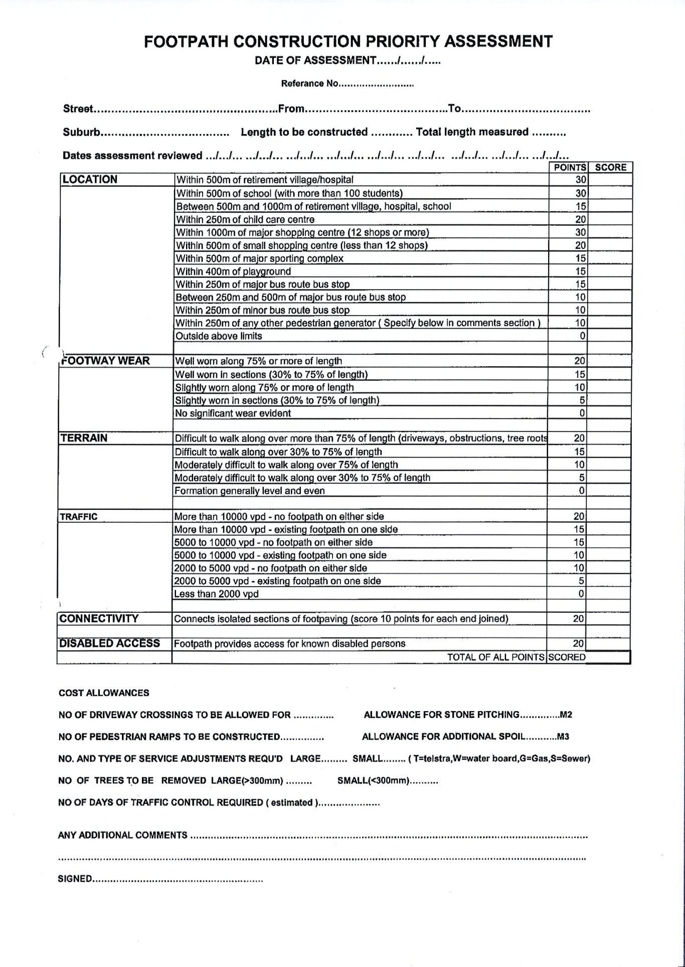

**Track Marker Strategy**

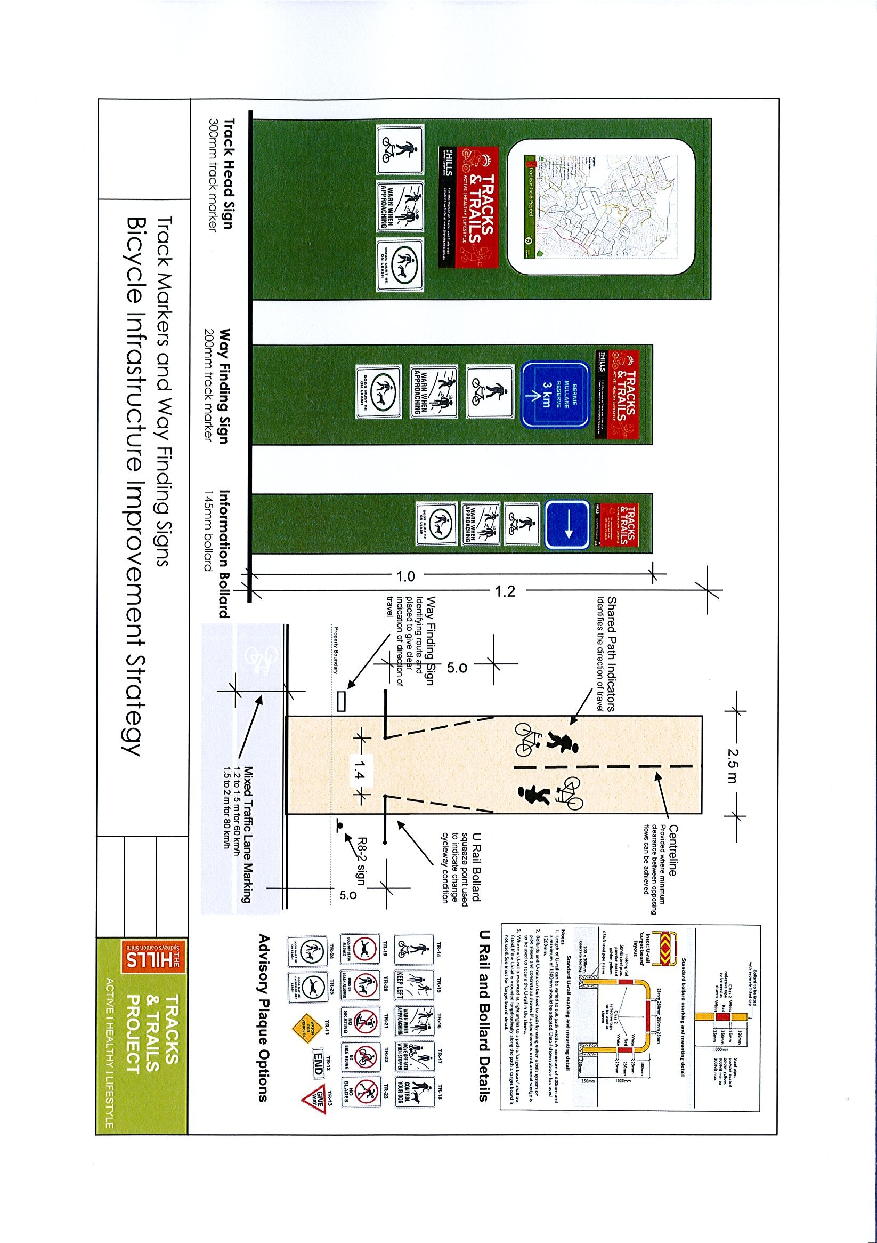

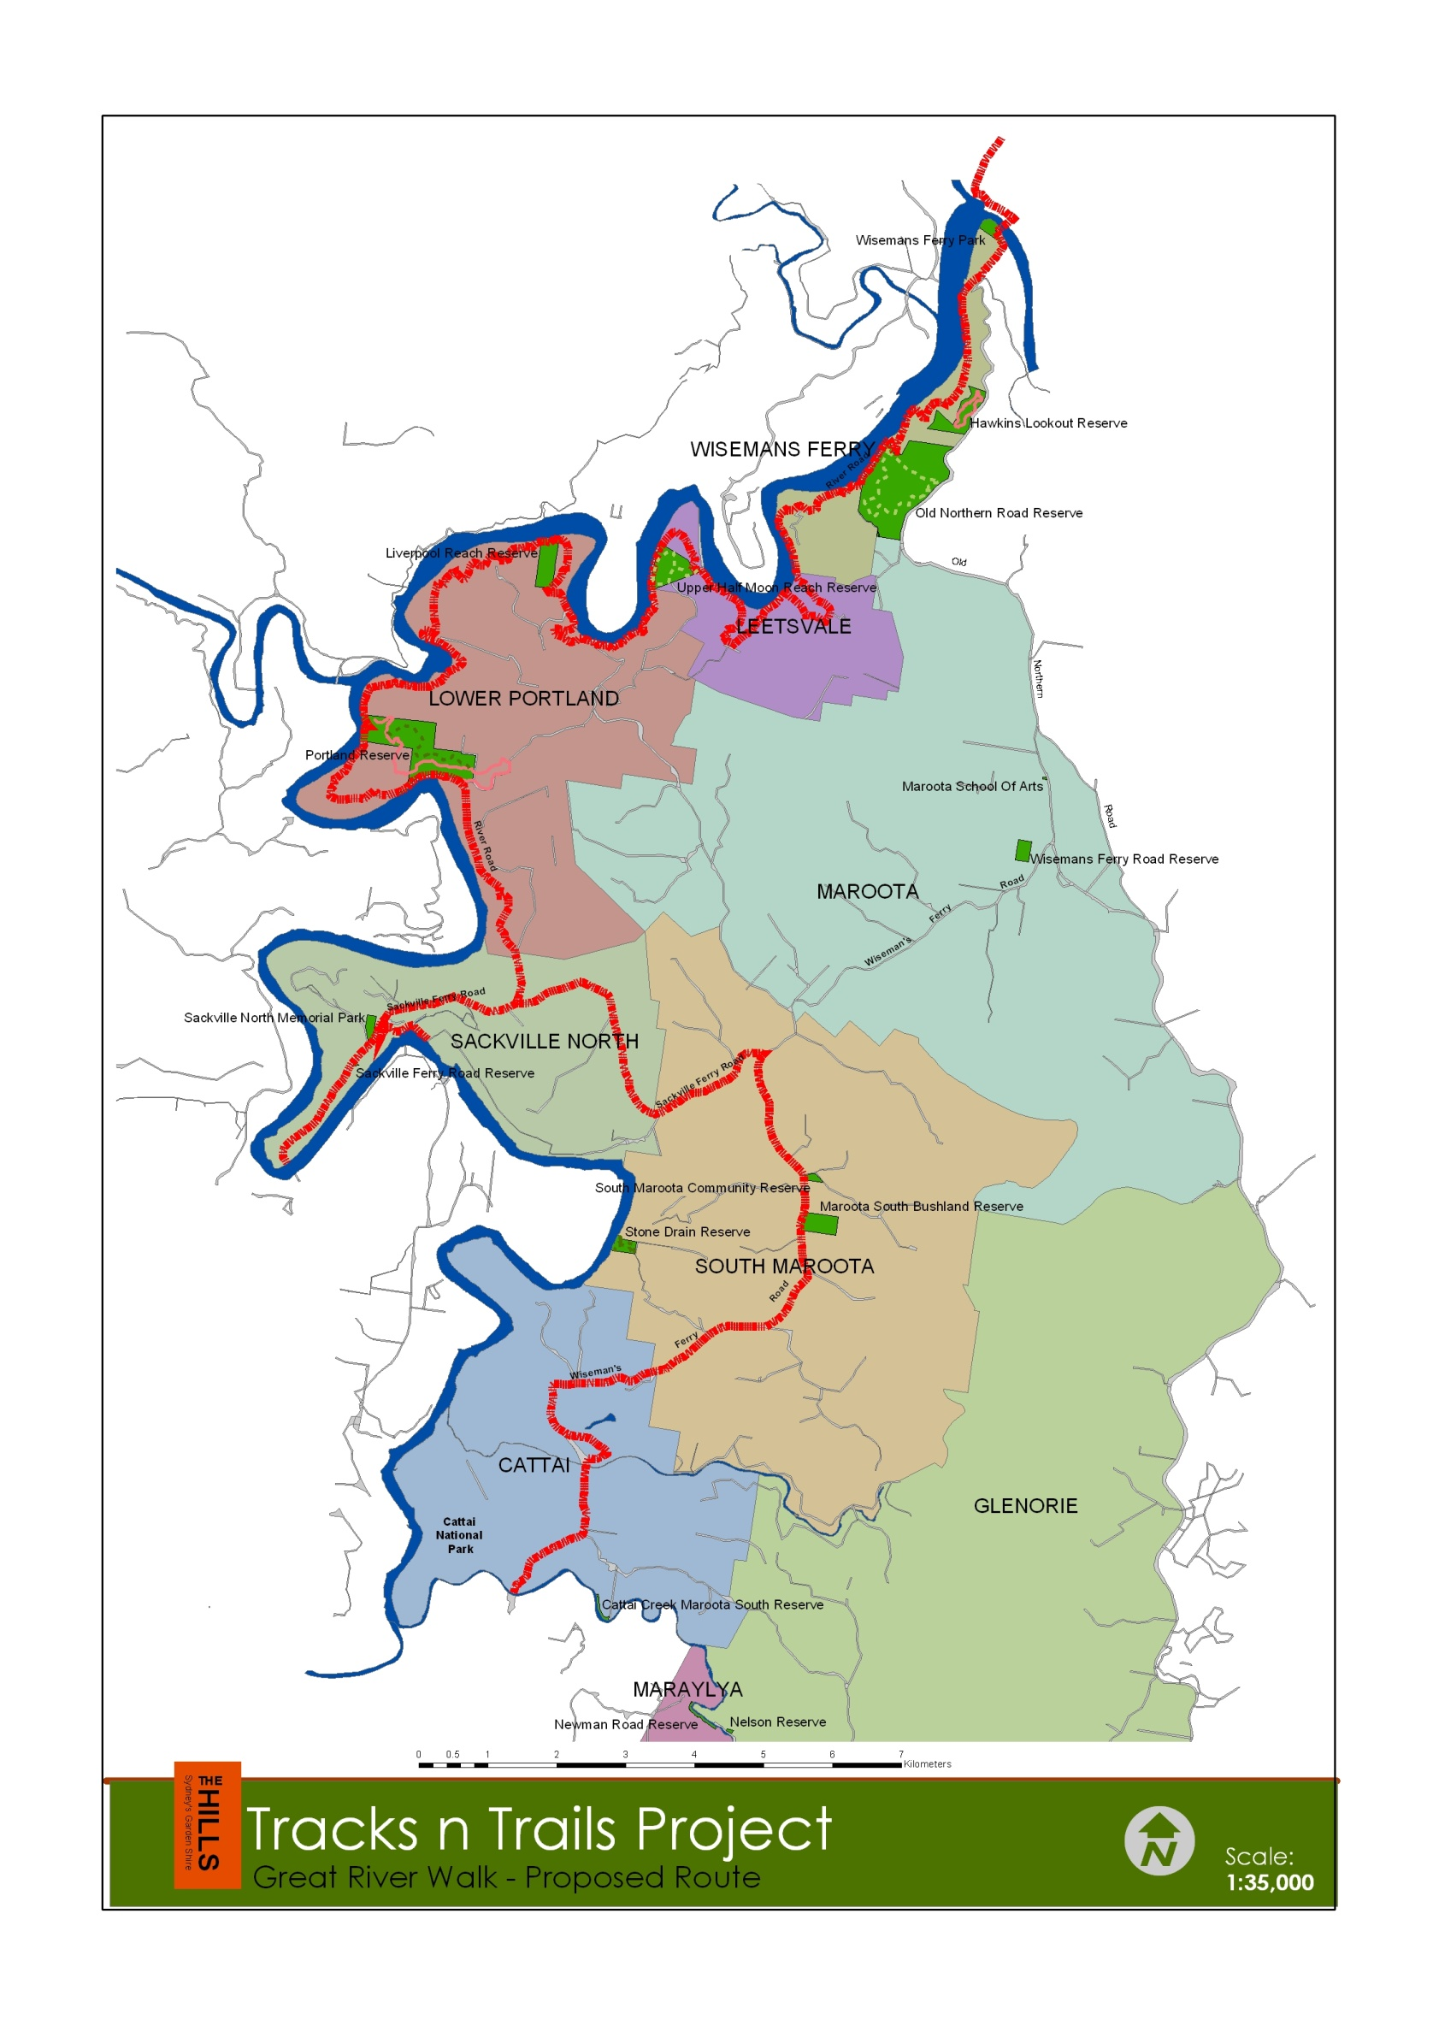**Great River Walk – Proposed Route**

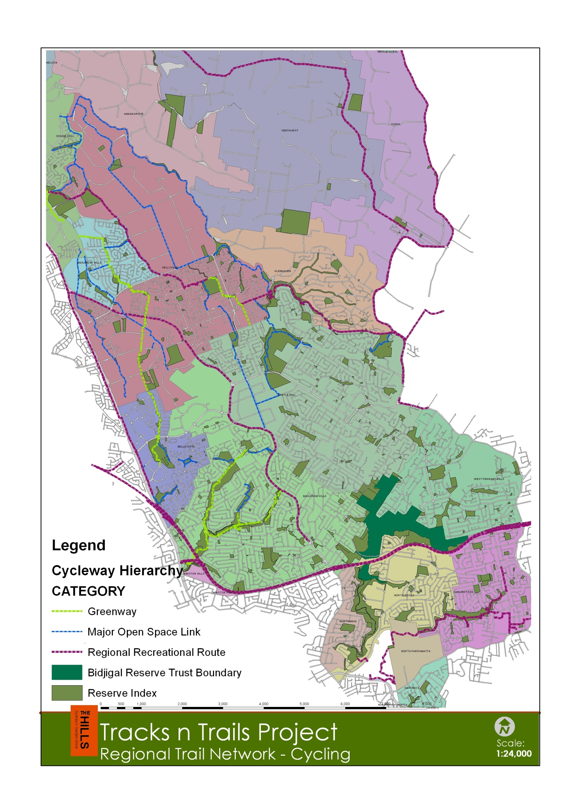**Regional Cycleways Network**

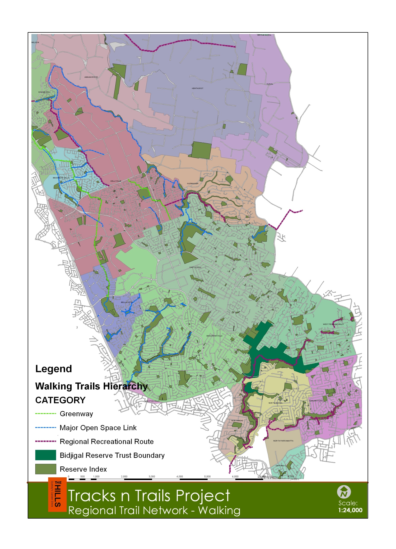**Regional Walking Trails Network**

1. Baulkham Hills Shire Council Recreation Strategy, 2007. Stracorp p.8-9
2. Impact of Urban Sprawl, Overweight, Obesity and Physical Activity in Sydney, Australia, 2008. L. Garden and B Jalaludin